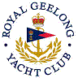 | Royal Geelong Yacht Club Inc.  Est 1859
Trophy Deed of Gift.

Trophy: | Glover Memorial Trophy
Presented by: | Jos Glover
Date: | 1946
For: | Outer Harbour Race
Remarks / Revisions | Commemorates Jos Glover.  Life member and Benefactor.  This Trophy has two inscribed bases
Click here for a List of Recipients
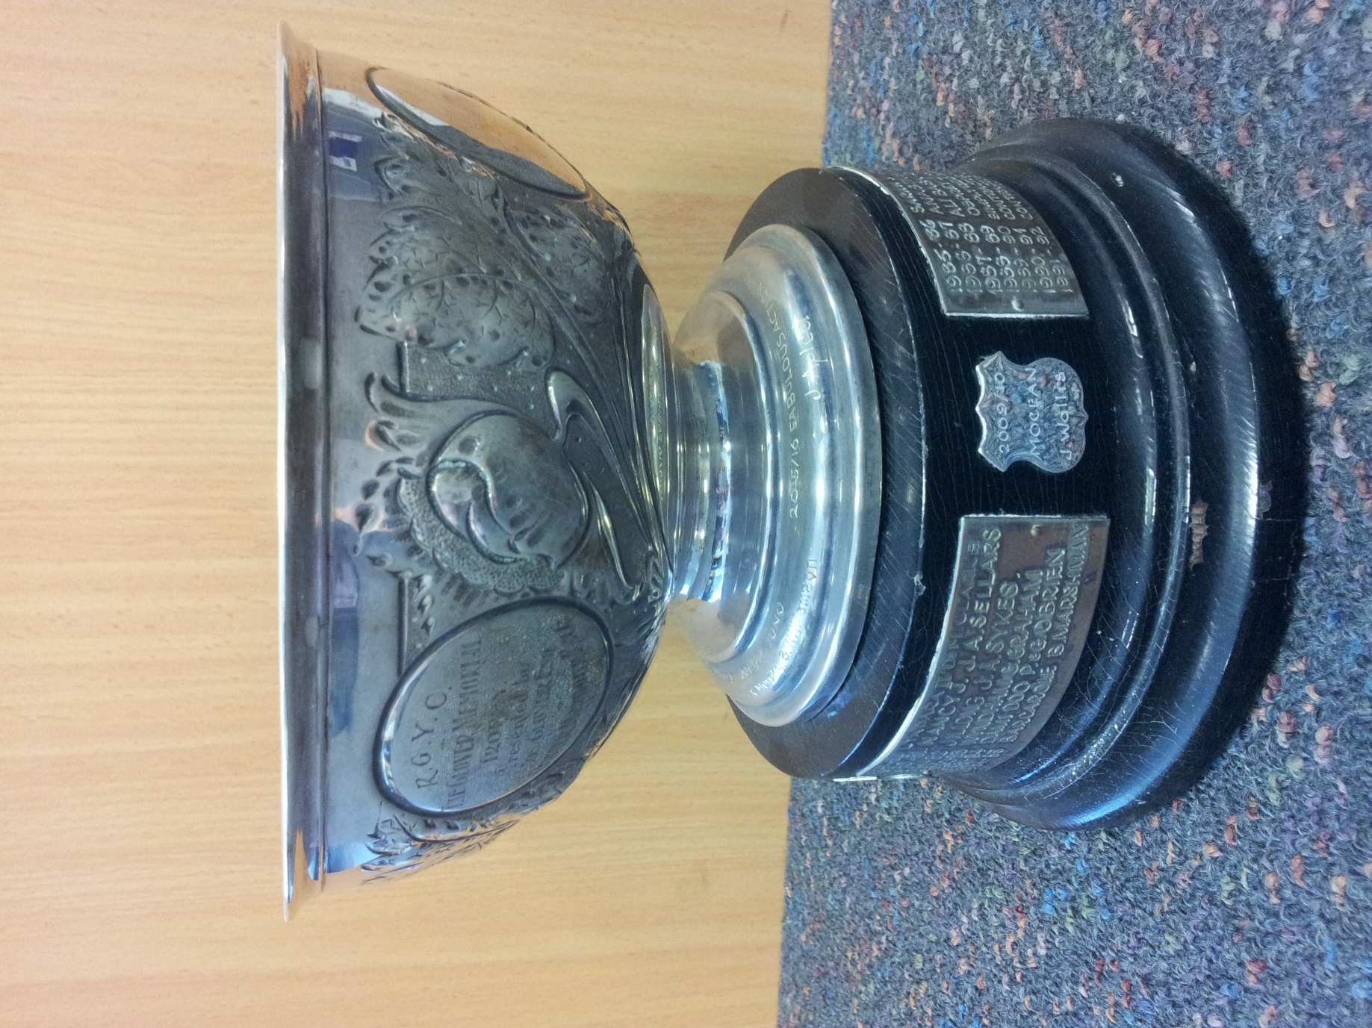
Traditionally, this race was conducted on a Sunday, with a 09:00 start time.
- It was a combined Div 1 and Div 2 race.
- The course was
  - Start
  - Leave 3 red piles in North channel to Starboard
  - ‘Drysdale” Cluster beacon to Port
  - Outer Explosives pile to Port
  - Arthur the Great Buoy to Port
  - Outer Explosives pile to Starboard
  - Half-Way Pile to Starboard (also known as the Steam Boat Pile)
  - Hopetoun Channel beacons 1,3,5,7,9,11,13,15, to Starboard
  - Hopetoun Channel beacons 2, 4, 6, 8, 10, 12, 14, 16, to Port
  - Finish

